Refining Selections:

- DINSTINCT CLAUSE

Remove duplicates values.

- SELECT author_lname FROM books;

- SELECT DISTINCT author_lname FROM books;

- SELECT author_fname, author_lname FROM books;

- SELECT DISTINCT CONCAT(author_fname,' ', author_lname) FROM books;

- SELECT DISTINCT author_fname, author_lname FROM books;

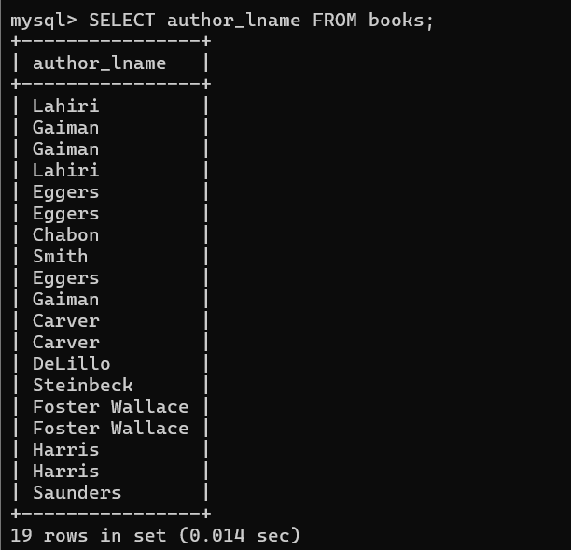

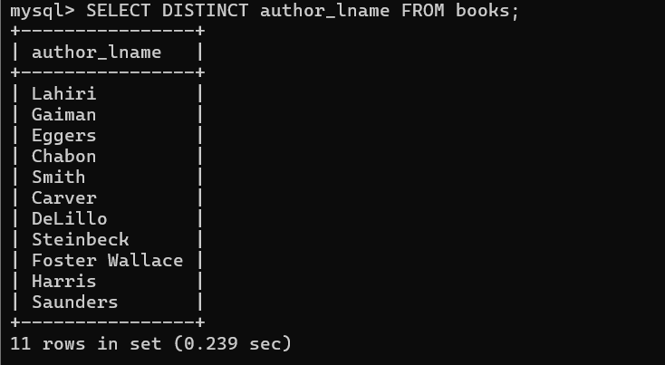

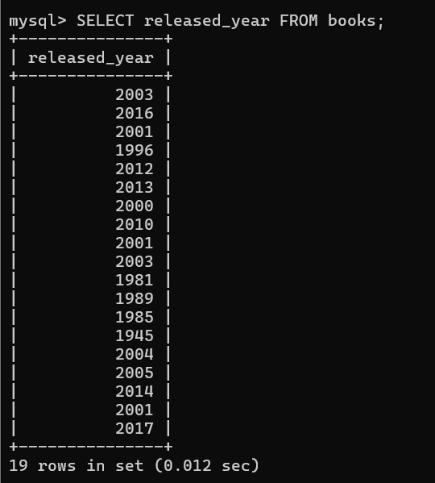

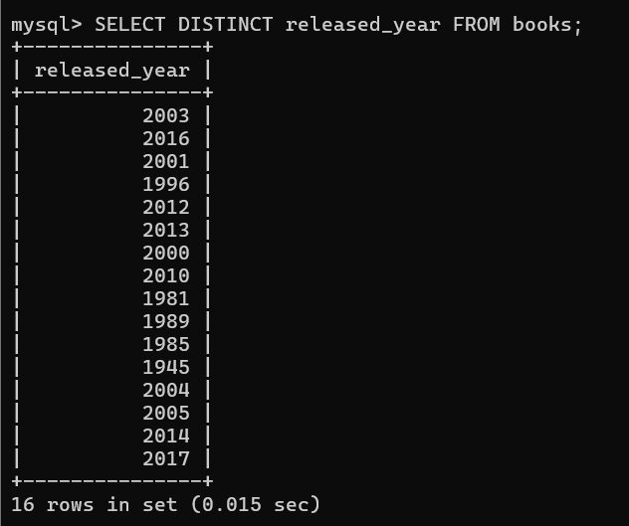

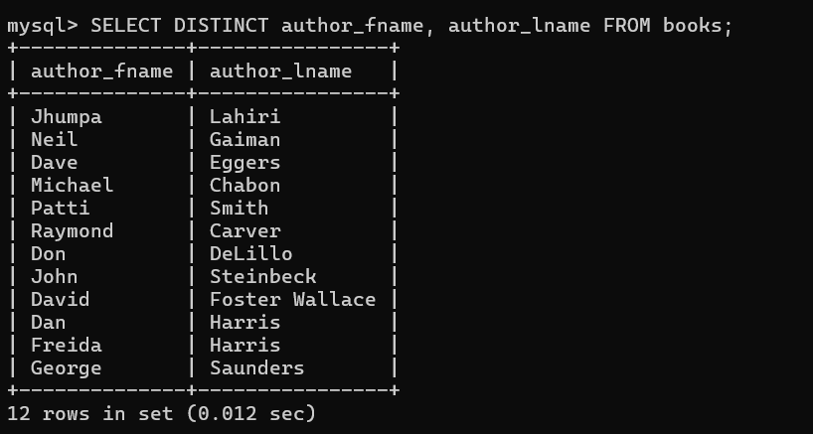

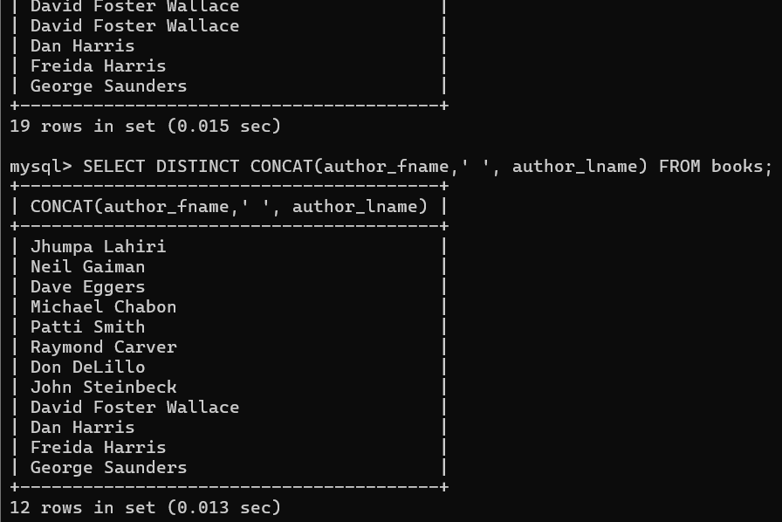

- ORDER BY

Sorting our results.

- SELECT * FROM books
- ORDER BY author_lname;

- SELECT * FROM books
- ORDER BY author_lname DESC;

- SELECT * FROM books
- ORDER BY released_year;

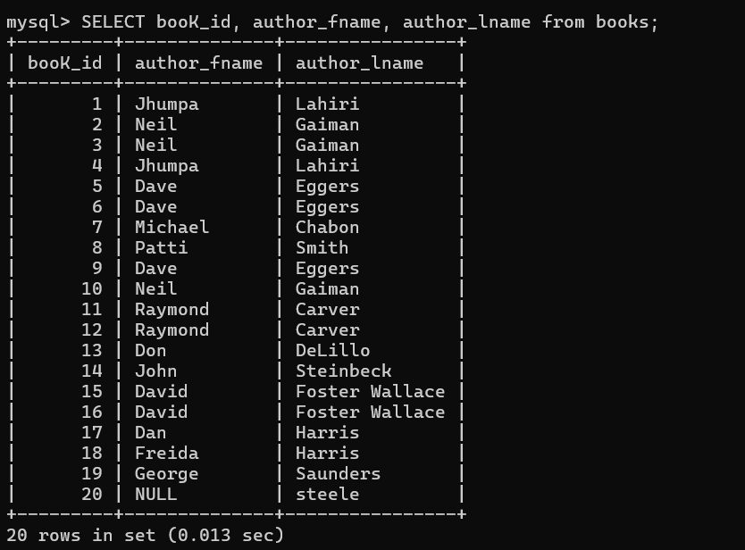

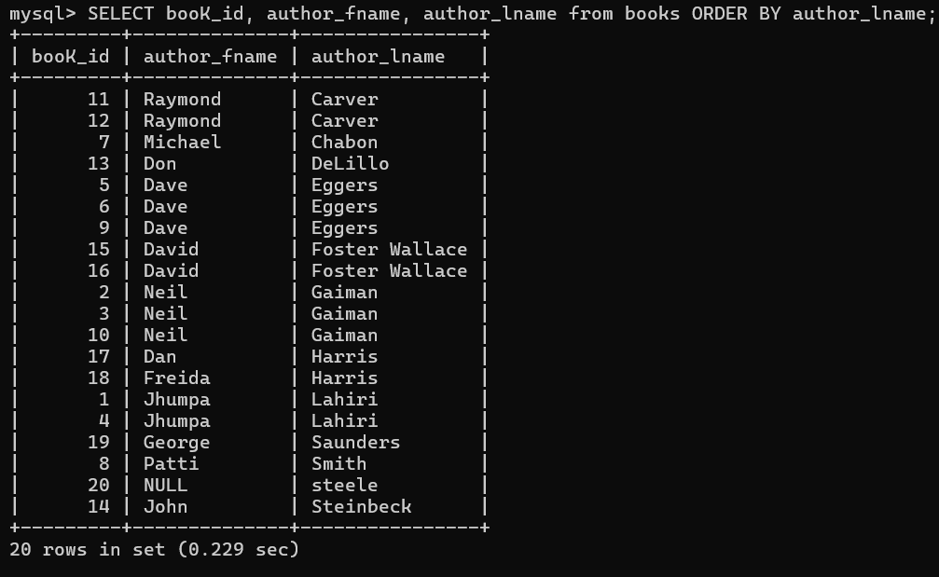

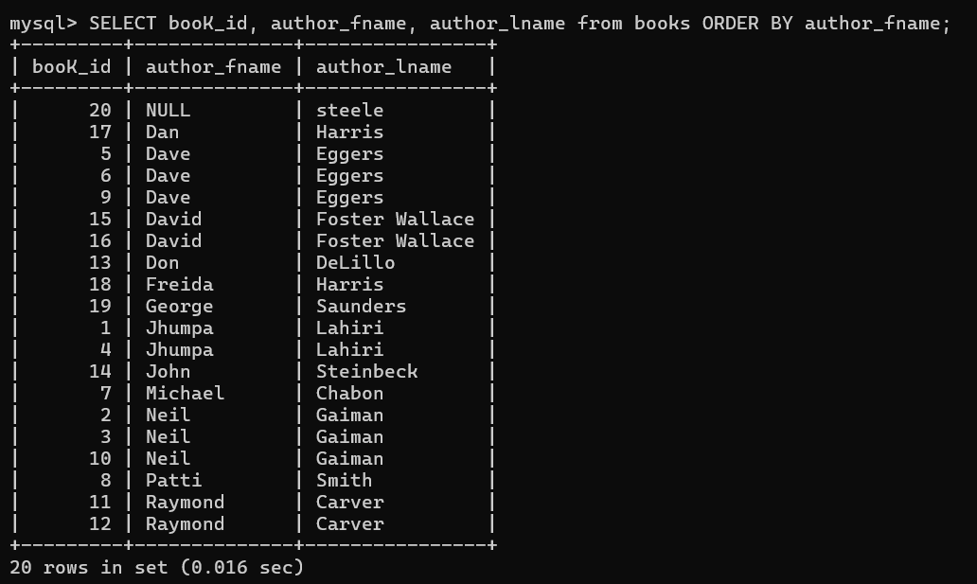

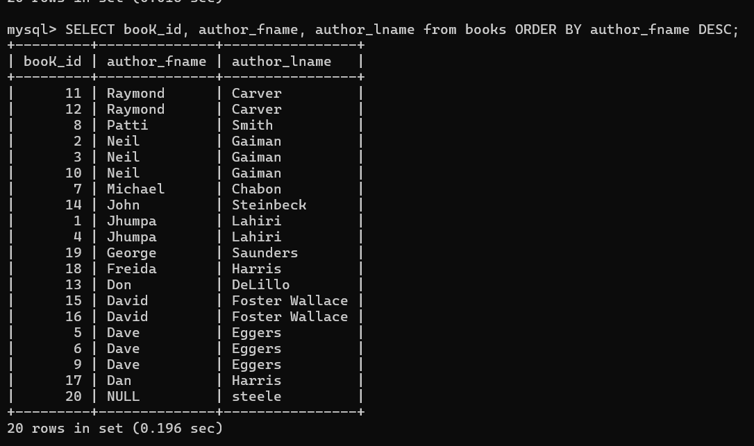

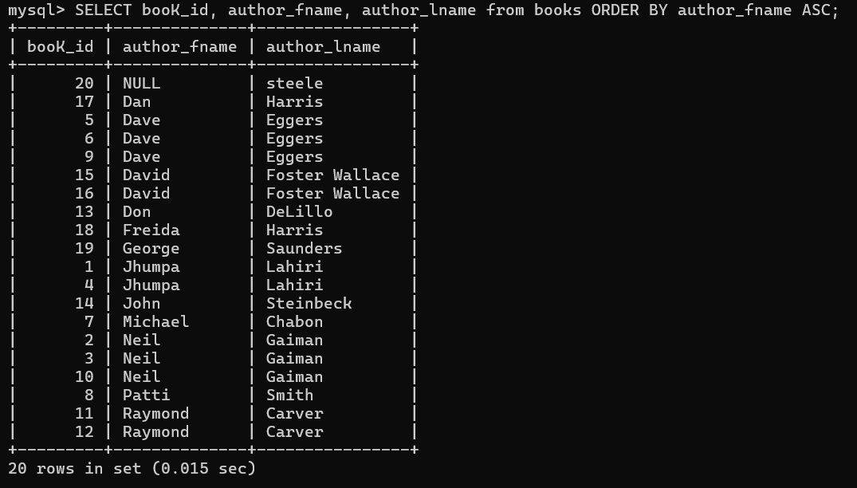

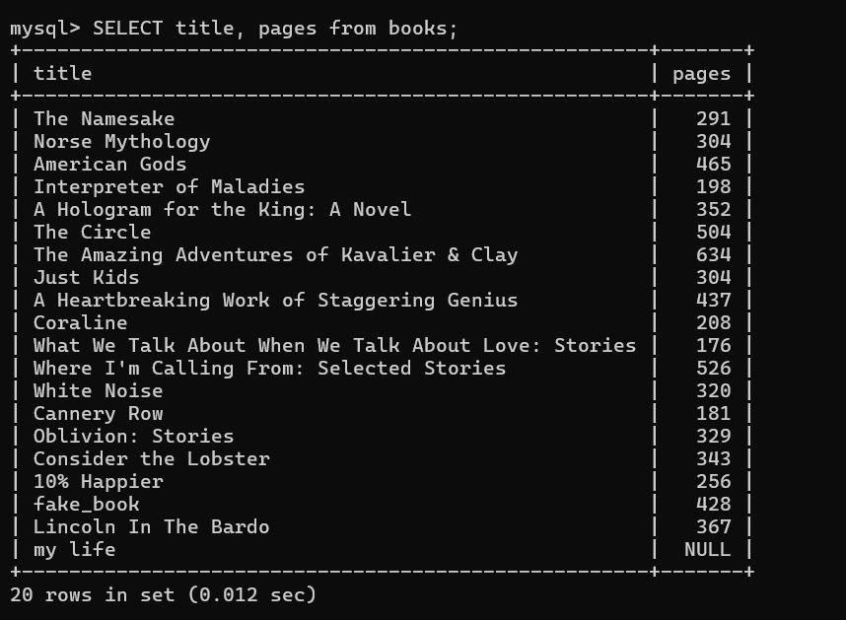

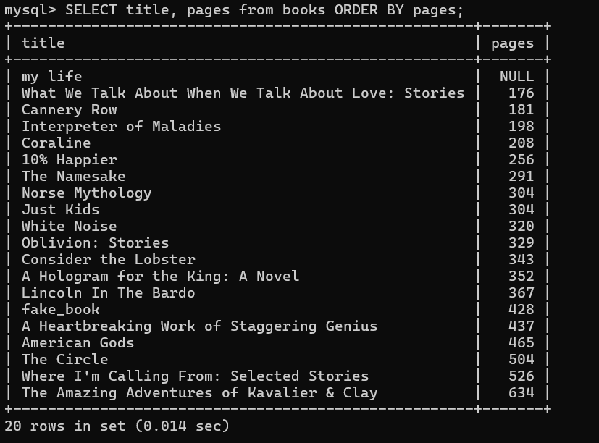

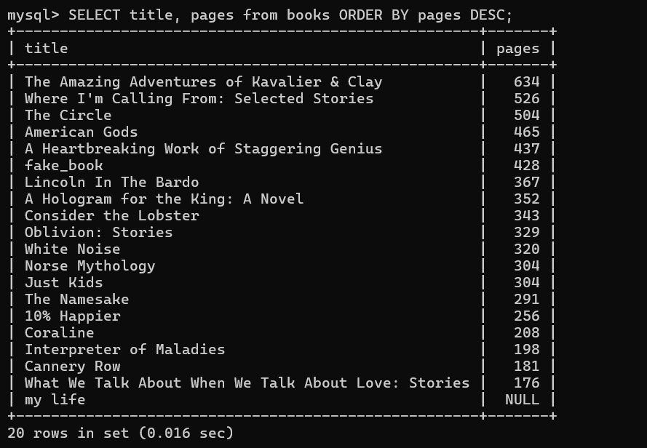

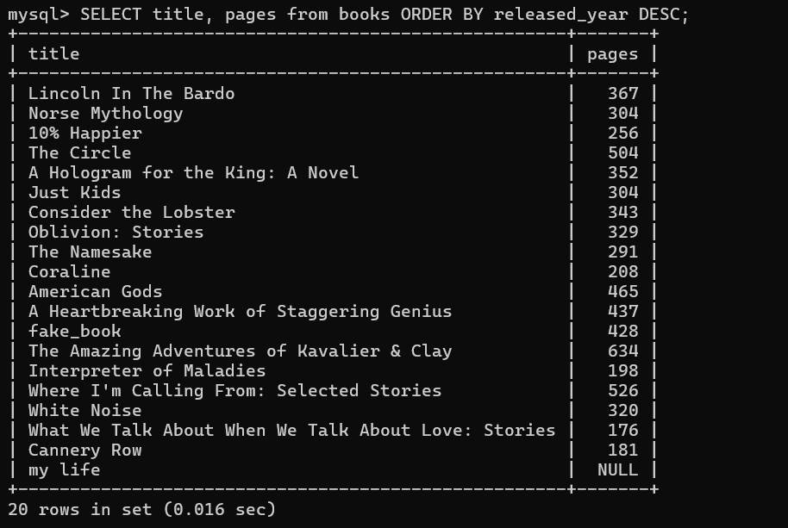

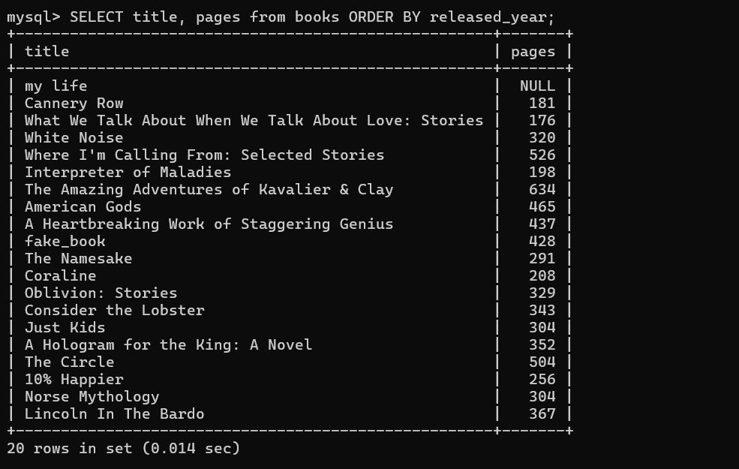
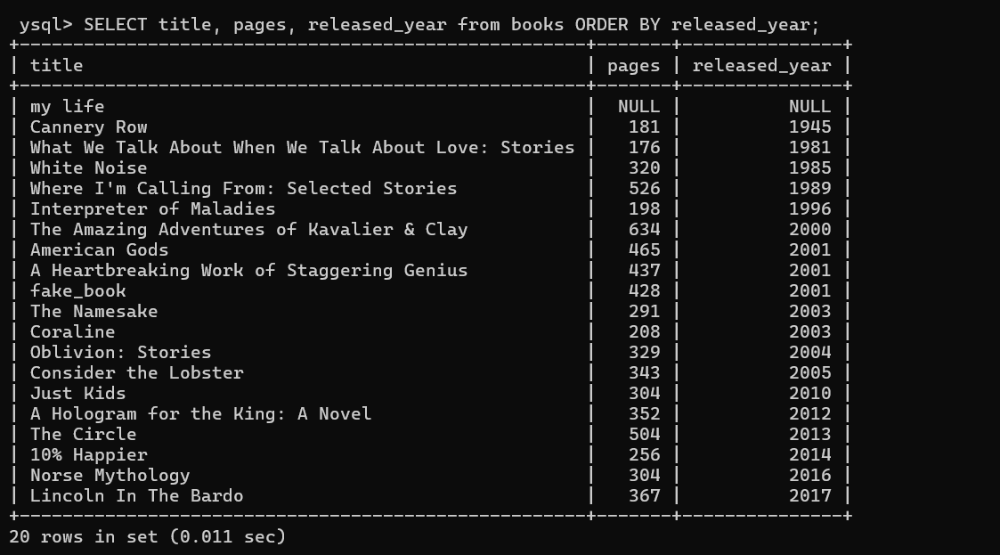

Order by part-2

- SELECT book_id, author_fname, author_lname, pages
- FROM books ORDER BY 2 desc;
- SELECT book_id, author_fname, author_lname, pages
- FROM books ORDER BY author_lname, author_fname;

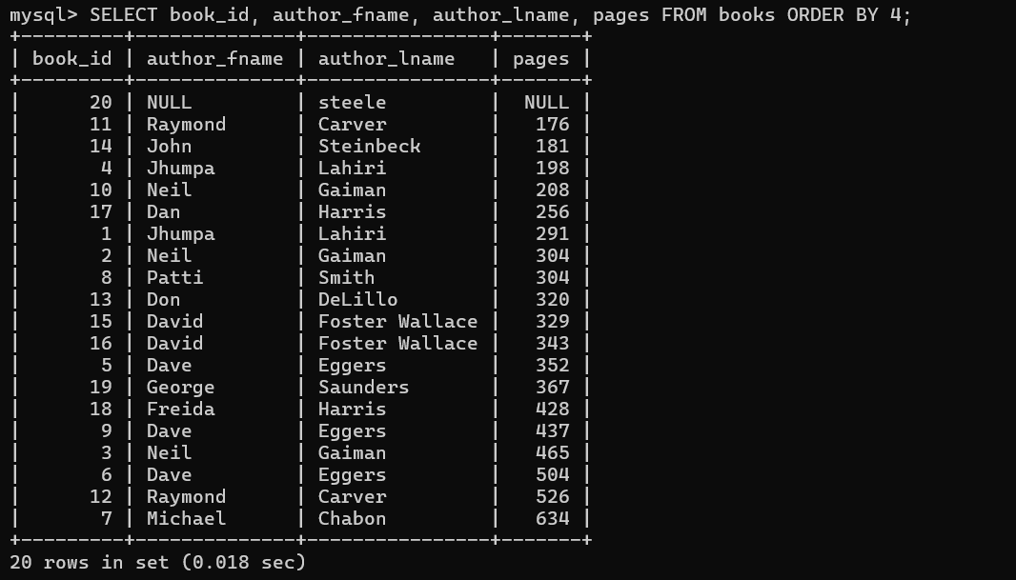

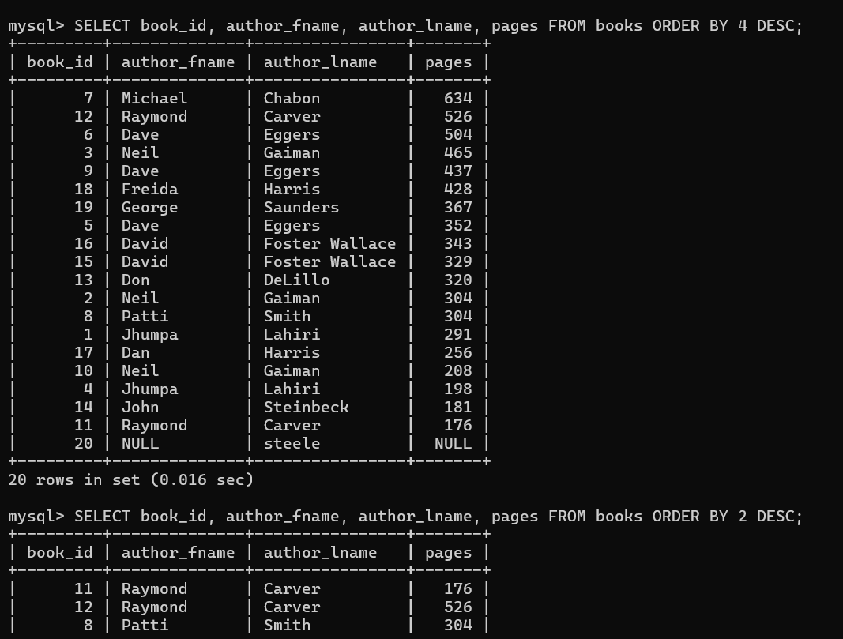

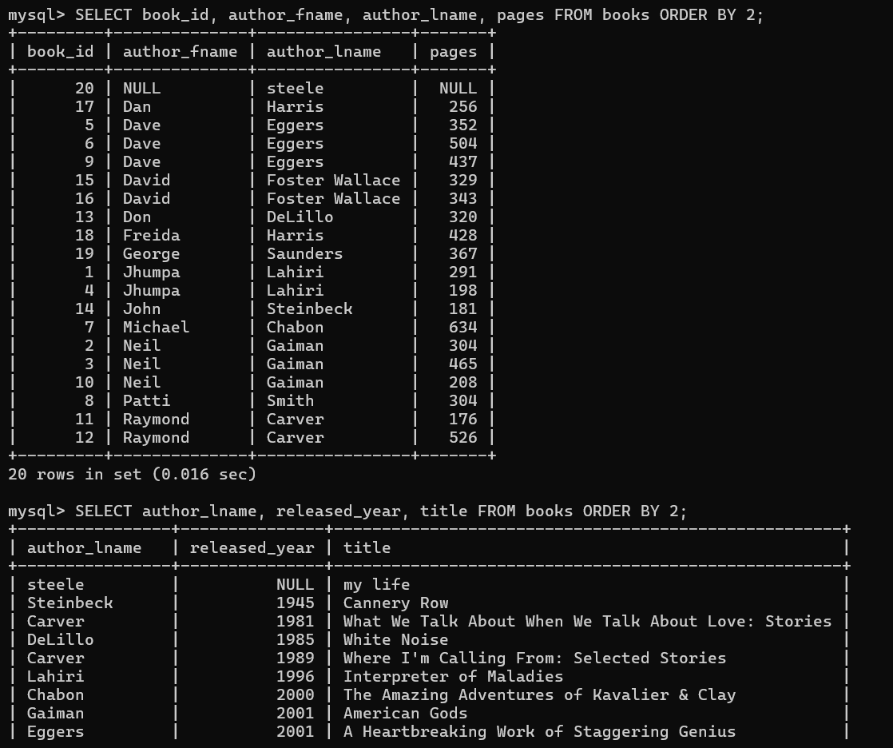

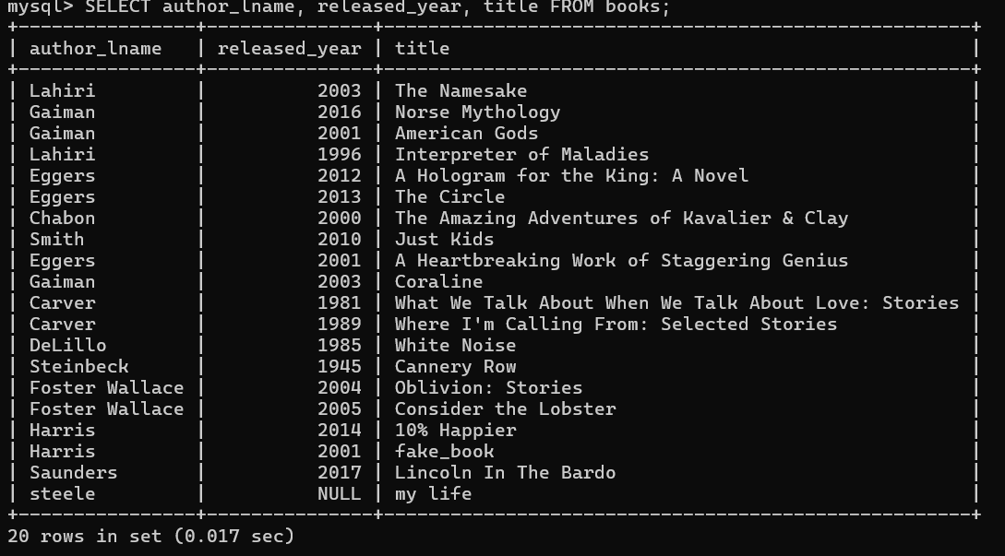

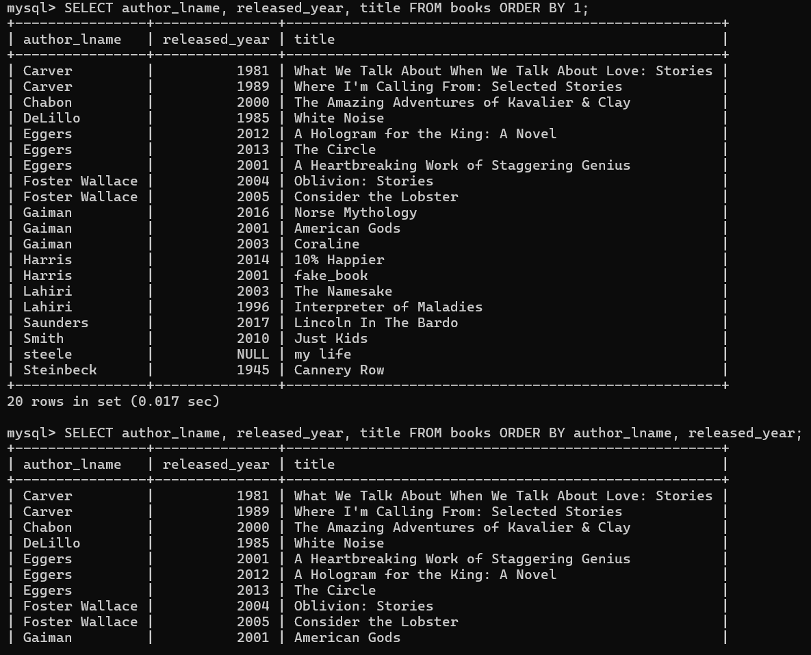

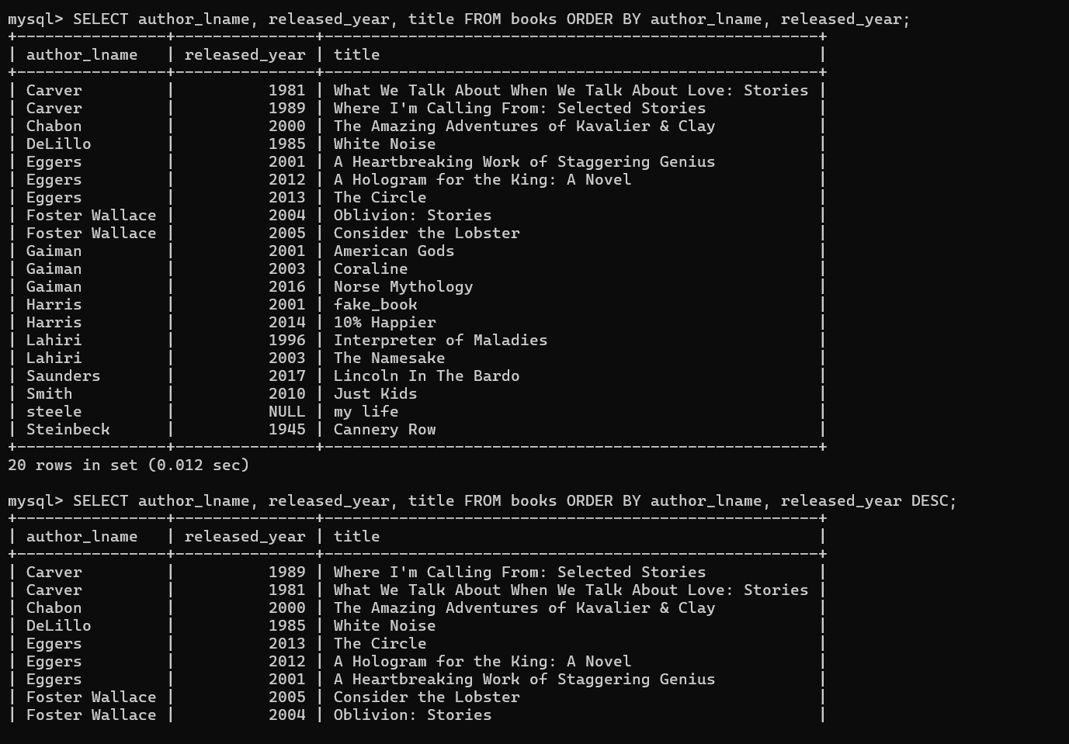

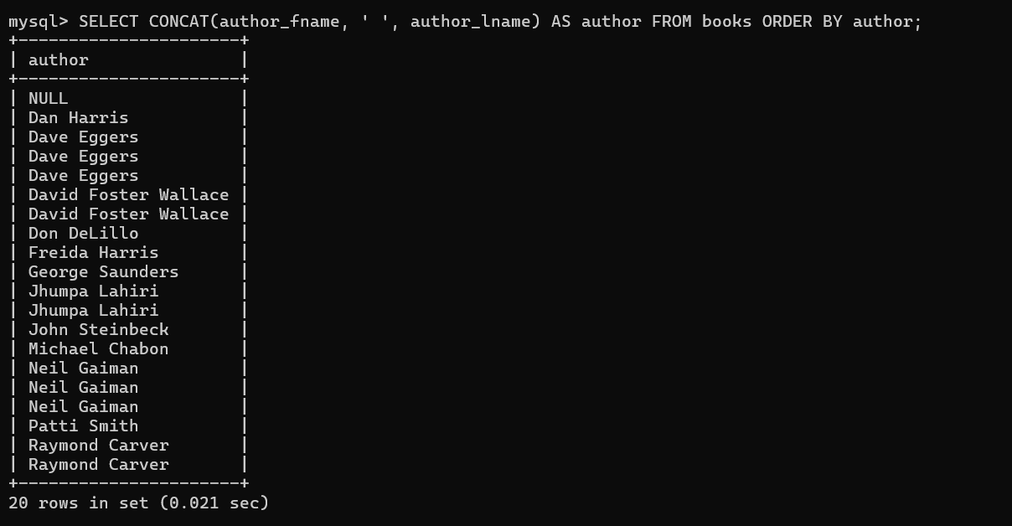

4. LIMIT

SELECT title FROM books LIMIT 10;
SELECT * FROM books LIMIT 1;
SELECT title, released_year FROM books
ORDER BY released_year DESC LIMIT 5;
SELECT title, released_year FROM books
ORDER BY released_year DESC LIMIT 1;
SELECT title, released_year FROM books
ORDER BY released_year DESC LIMIT 14;
SELECT title, released_year FROM books
ORDER BY released_year DESC LIMIT 0,5;
SELECT title, released_year FROM books
ORDER BY released_year DESC LIMIT 0,3;

SELECT title, released_year FROM books
ORDER BY released_year DESC LIMIT 1,3;
SELECT title, released_year FROM books
ORDER BY released_year DESC LIMIT 10,1;
SELECT * FROM books LIMIT 95,18446744073709551615;
SELECT title FROM books LIMIT 5;
SELECT title FROM books LIMIT 5, 123219476457;
SELECT title FROM books LIMIT 5, 50;

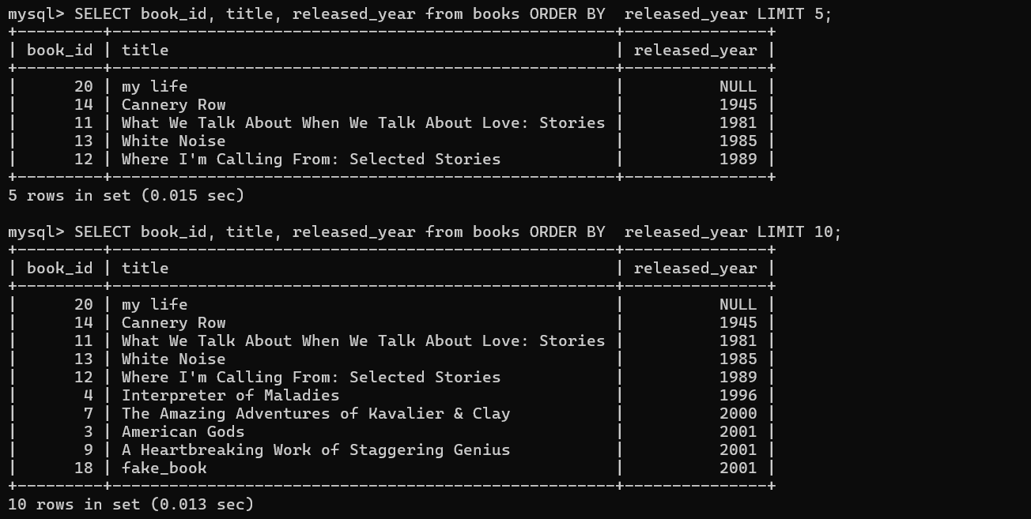

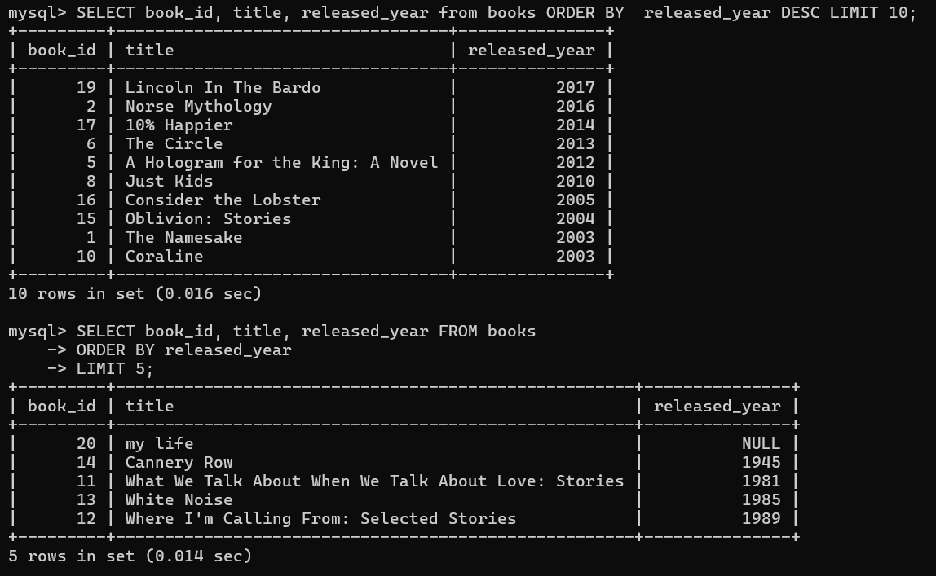

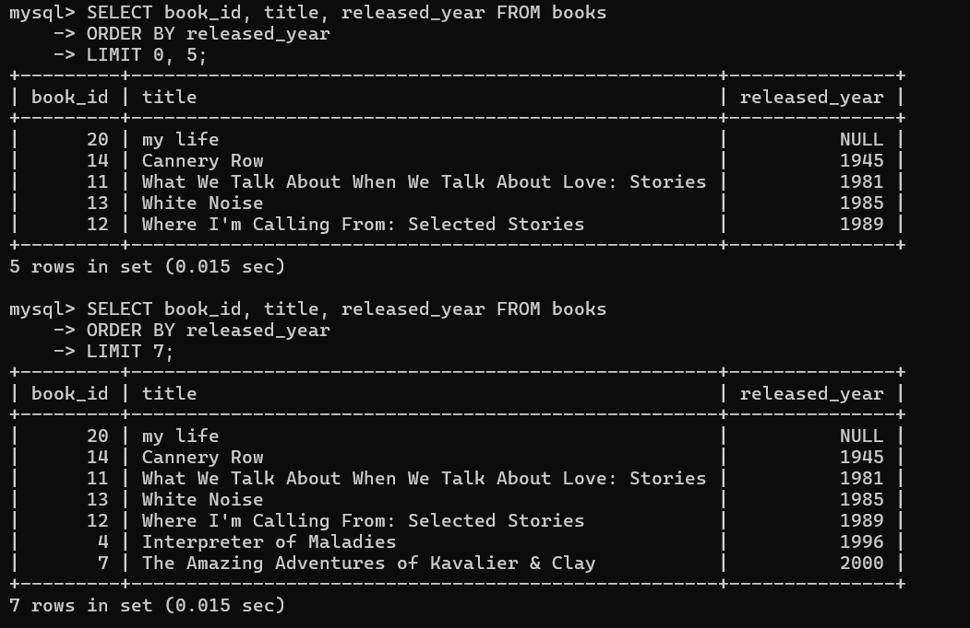
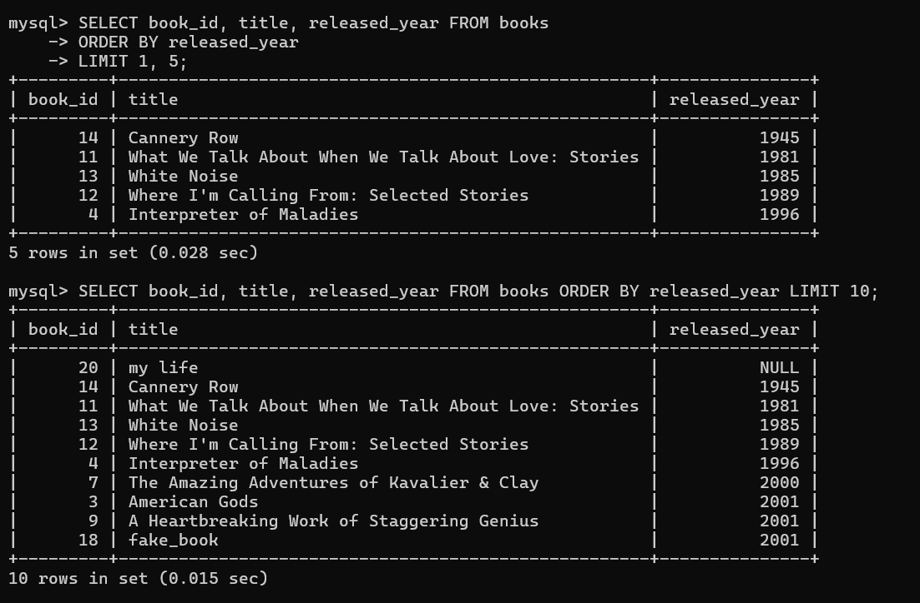

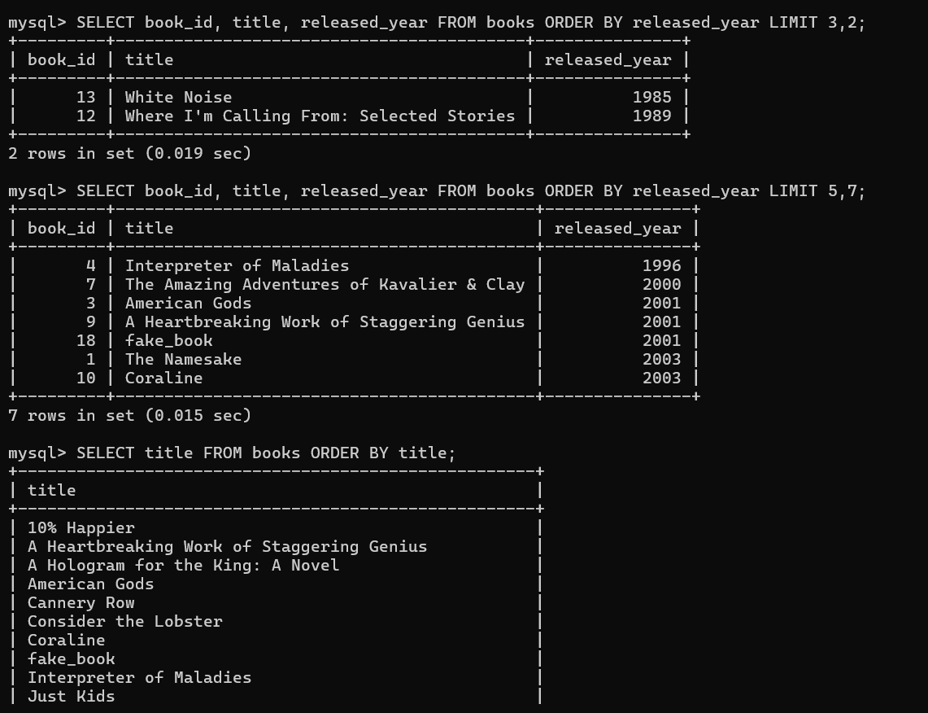

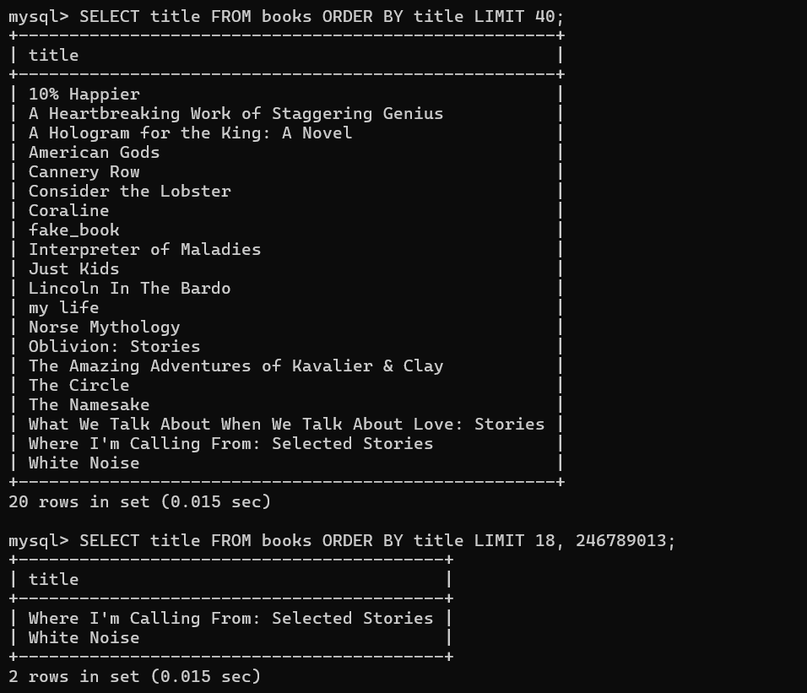

SELECT book_id, title from books LIMIT 5,7;
5->ROWS count start with 0.
7->COUNT
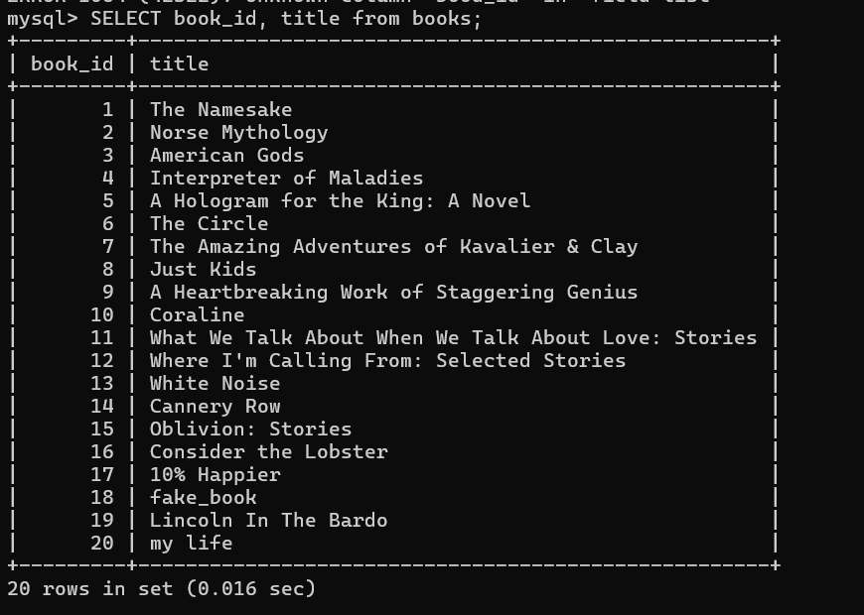

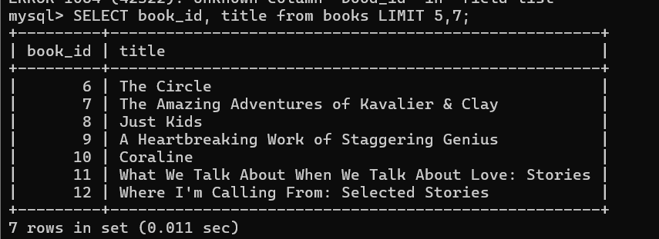

5. LIKE CMD

Better Searching

SELECT title, author_fname, author_lname, pages
FROM books
WHERE author_fname LIKE '%da%';
SELECT title, author_fname, author_lname, pages
FROM books
WHERE title LIKE '%:%';
SELECT * FROM books
WHERE author_fname LIKE '____';
SELECT * FROM books
WHERE author_fname LIKE '_a_';

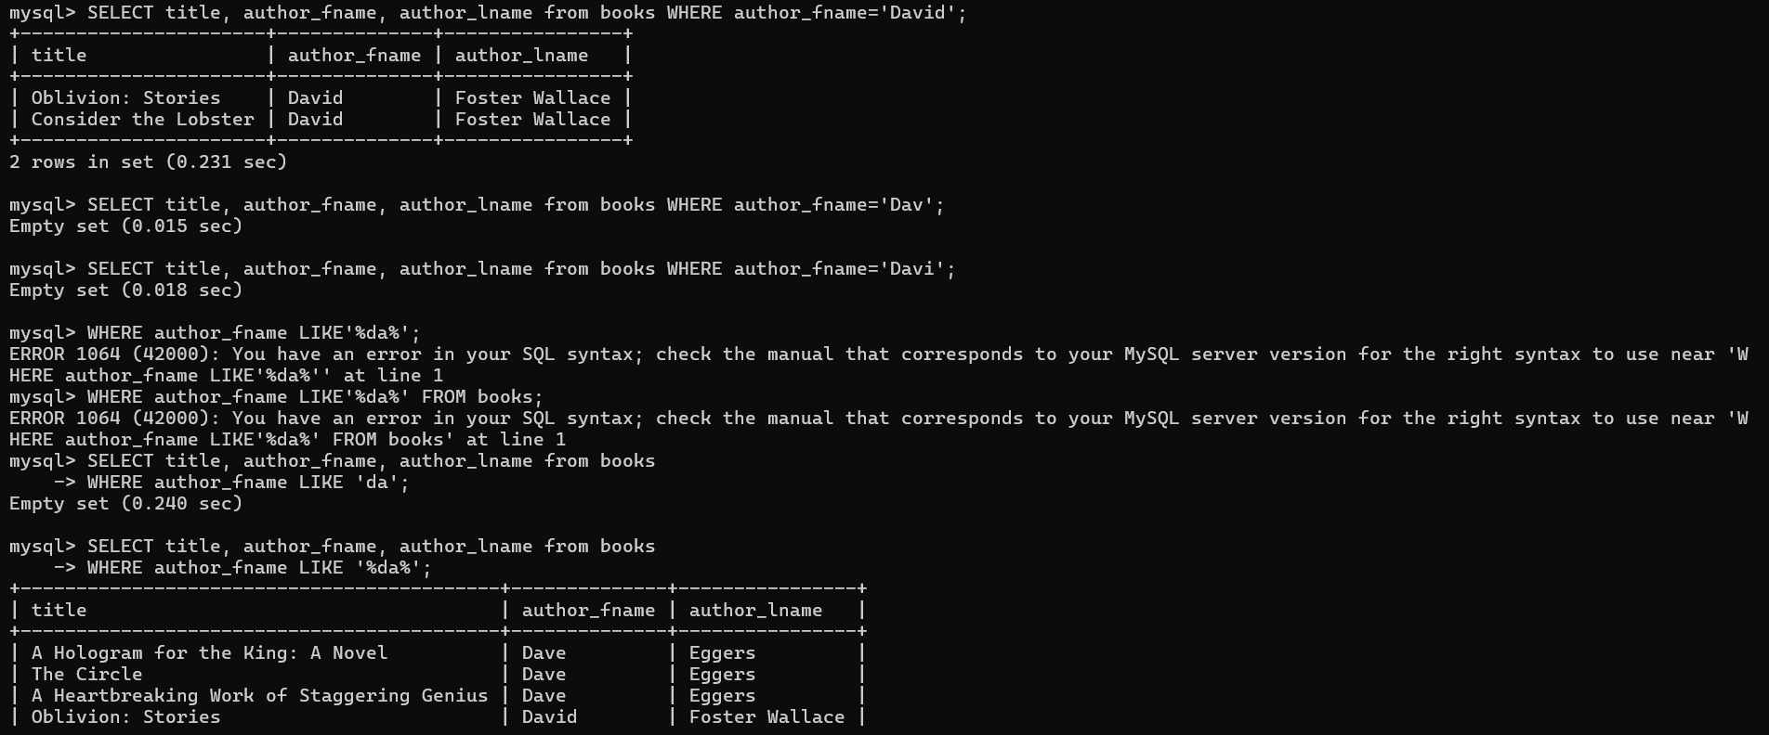

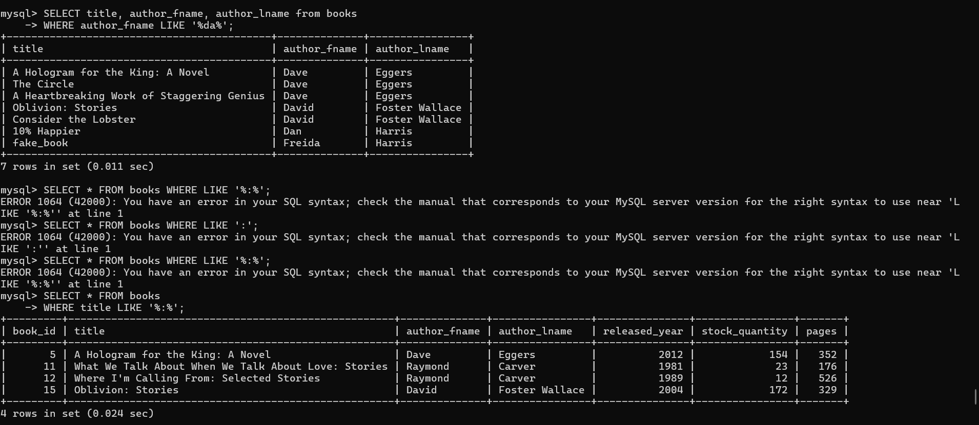

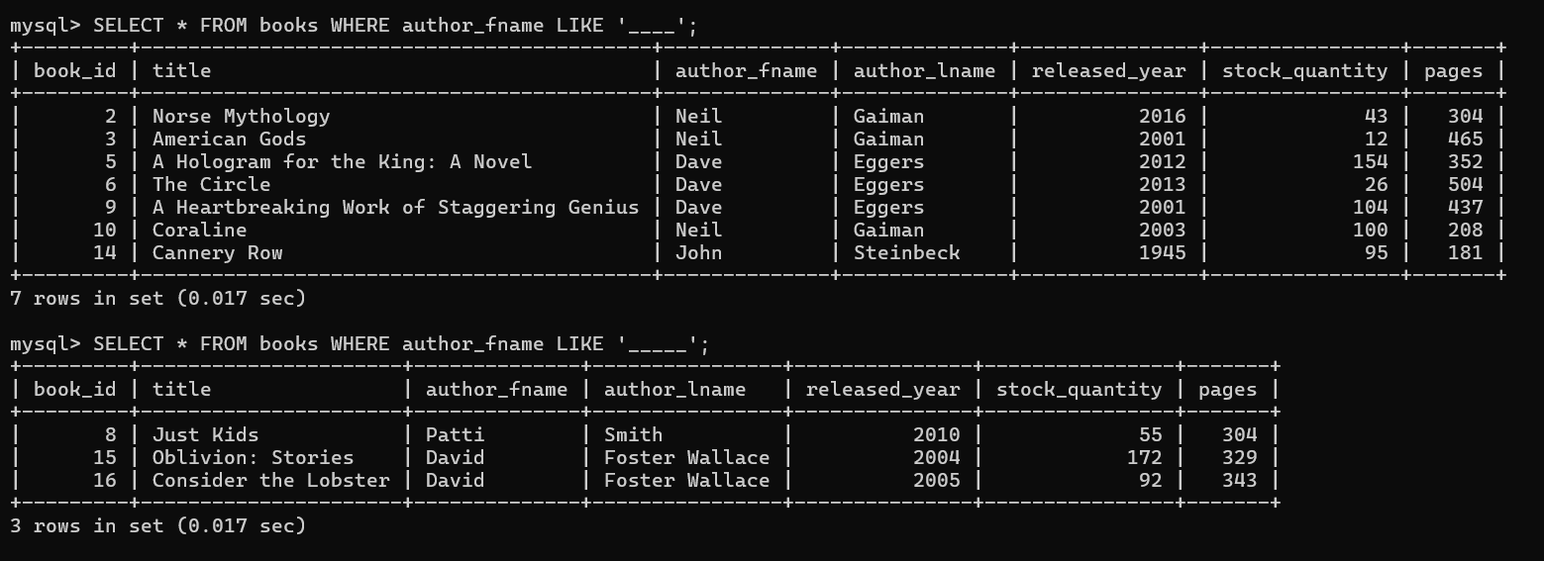

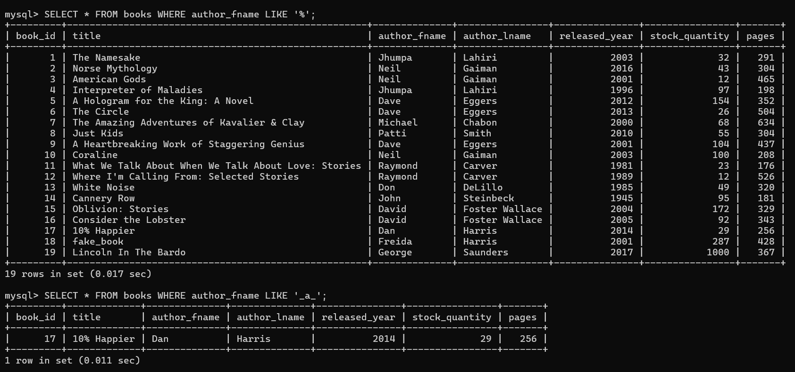

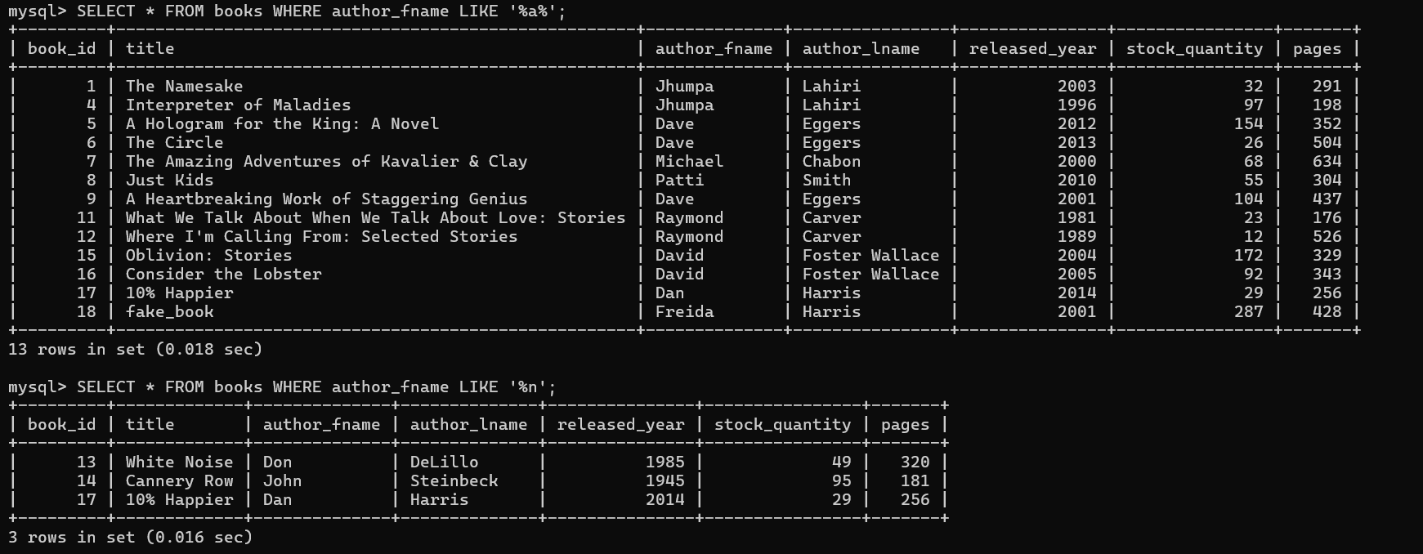

6. Escaping wildcards code
Like part-2
-- To select books with '%' in their title:
SELECT * FROM books
WHERE title LIKE '%\%%';

-- To select books with an underscore '_' in title:
SELECT * FROM books
WHERE title LIKE '%\_%';

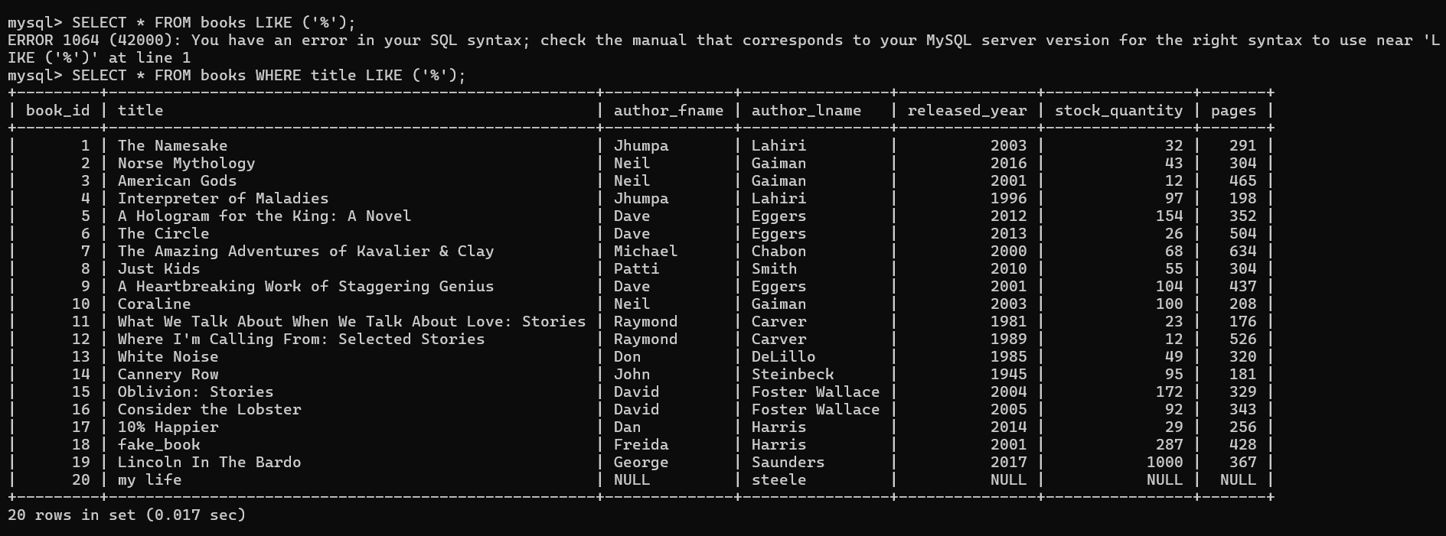

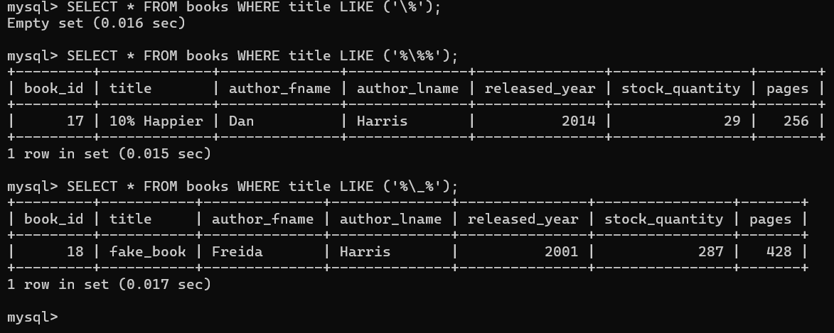

Exercise
SELECT title FROM books WHERE title LIKE '%stories%';

SELECT title, pages FROM books ORDER BY pages DESC LIMIT 1;

SELECT CONCAT(title, ' - ', released_year) AS summary FROM books ORDER BY released_year DESC LIMIT 3;

SELECT title, author_lname FROM books WHERE author_lname LIKE '% %';

SELECT title, released_year, stock_quantity FROM books ORDER BY stock_quantity LIMIT 3;

SELECT title, author_lname FROM books ORDER BY author_lname, title;

SELECT title, author_lname FROM books ORDER BY 2,1;

SELECT CONCAT( 'MY FAVORITE AUTHOR IS ', UPPER(author_fname), ' ',
UPPER(author_lname), '!' ) AS yell
FROM books ORDER BY author_lname;

